L20 delta method

L13 beta posterior

L14 log-normal log-transformmed

L16 power

L17 regression

L19 relative risk odds ratio

L18 score-test wald-test

hw4 p7 profile likelihood

# Power

Z test

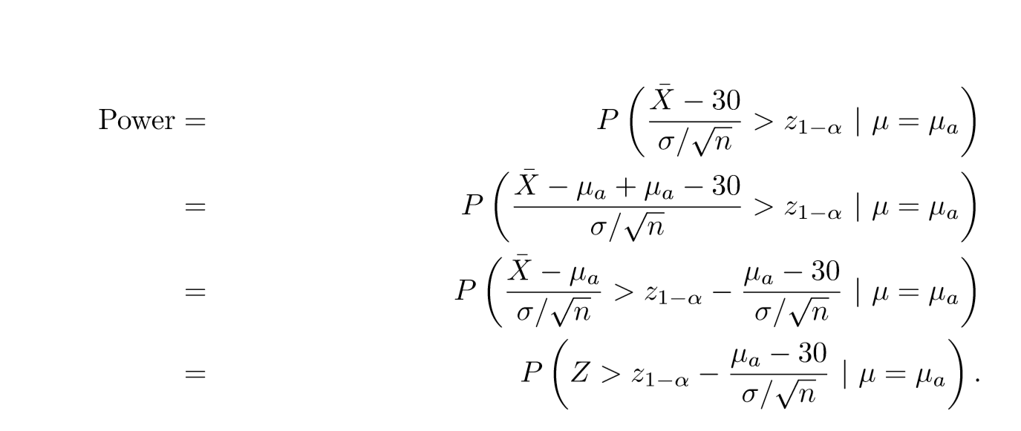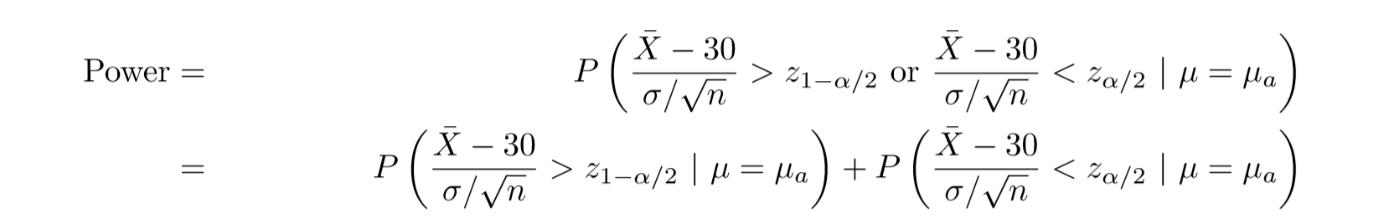T test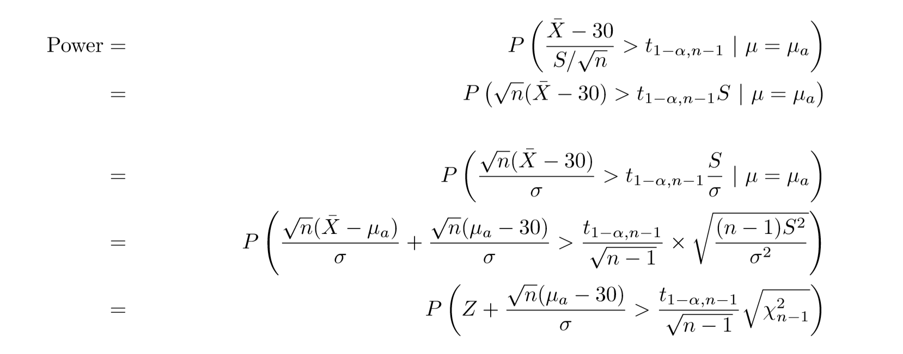

# Gamma

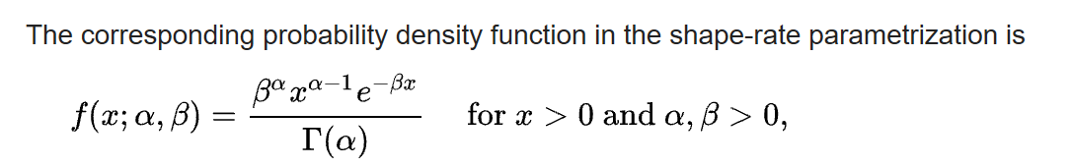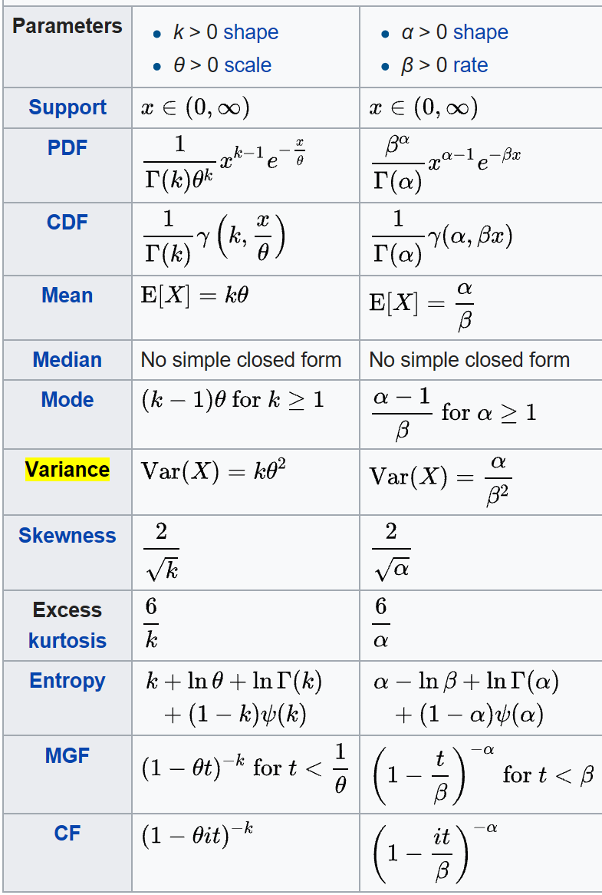

# Beta

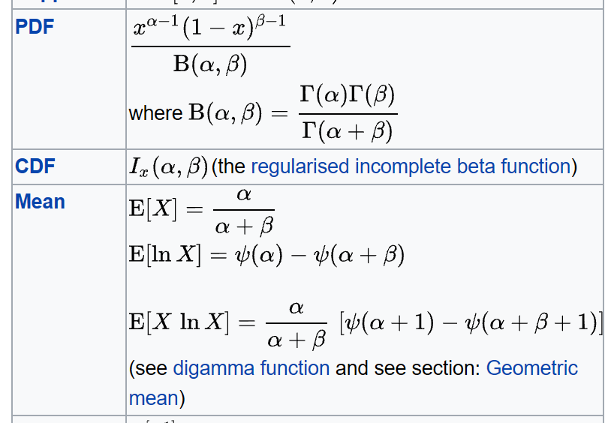

# Posterior

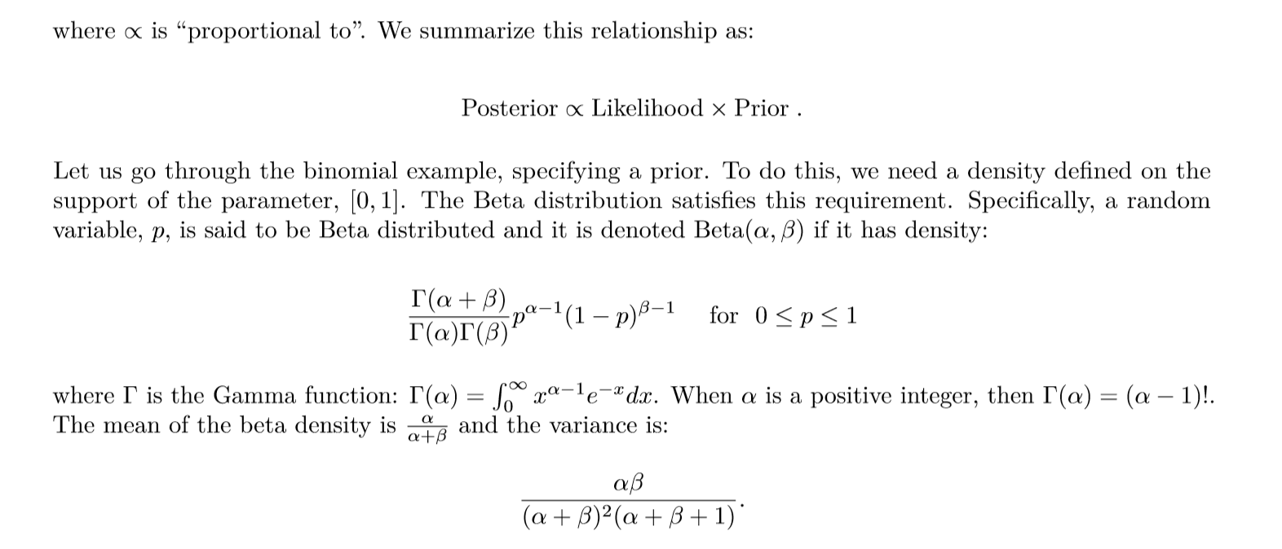

# Log

